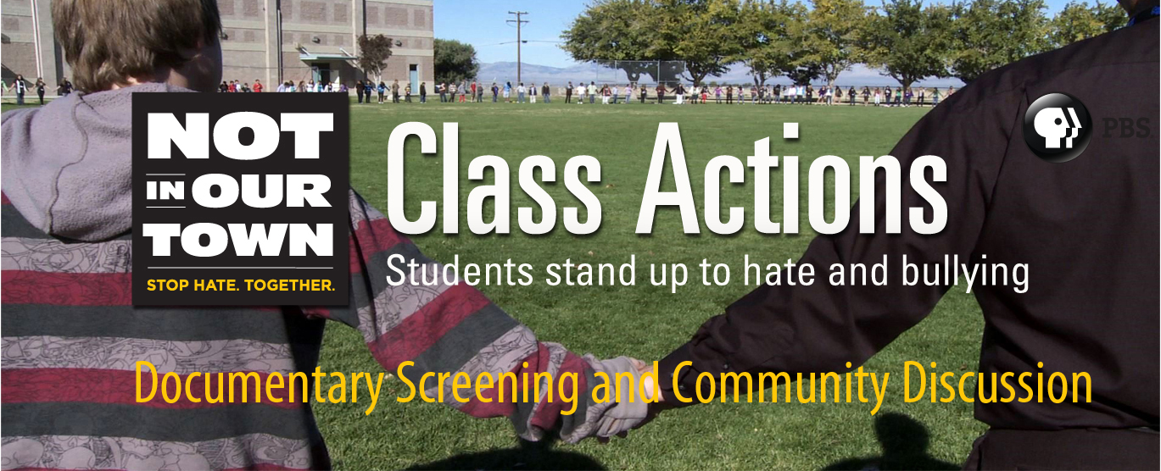

How can students and communities stand together
against hate and bullying?

Join us for a screening of Not In Our Town: Class Actions, the half-hour documentary about students and community members who are creating change in the wake of racism, anti-Semitism, and the traumatic consequences of bullying.

Date:
Time:
Location:
Contact:
Sponsors:

To learn more about Not In Our Town: Class Actions and Not In Our Town, visit www.NIOT.org/classactions or PBS.org/NIOT.
Not In Our Town: Class Actions will debut on Feb. 13, 2012 on PBS stations.
Check local listings.

